

CURRICULUM VALIDATION
EXTERNAL REVIEWER'S REPORT
Version 4.1. 2023

Dear Reviewer,

We would firstly like to express our thanks to you for agreeing to undertake a review of the following Curriculum Validation. Below you will find a template for organising your review.

The Curriculum Validation of public health programmes was introduced in September 2014. Curriculum Validation operates both as a stand-alone quality mark for curricula and also as a formal prerequisite to begin the process of programme and institutional accreditation.
The purpose of the Curriculum Validation is to ensure that the curriculum and its contents adhere to standards associated with a modern comprehensive degree offering through containing the basic structure and content expected from a Public Health focussed degree.
The aim of this review is to ensure that the programme / curriculum contains a public health focus and that there is coherence from the aims through to its implementation.
We would especially like to emphasise that this exercise is not solely for ‘checking’ but also for quality Improvement purposes and throughout the document you are invited to comment on any areas you may believe will be of benefit to the programme / curriculum. The reviews will be presented anonymously to the applicant as part of the Validation process.
Please complete the document in English and return to the APHEA Secretariat from where it will be passed on to the APHEA Board of Accreditation for a decision.
We warmly welcome any feedback or suggestions concerning this document and / or process you may have. Please do relate these back to the APHEA secretariat so we can continue to improve our service. We will provide you with a response on any decisions made as a result of your feedback.
Once again, we thank you for your time and efforts in this review.

Instructions for use:
In the following review template, you are asked to provide an assessment of the Curriculum Validation application based upon a series of statements (criteria) and how they are addressed, and evidence provided for, in the application and associated paperwork
The assessment score used throughout the document is the following:

Assessment score | Brief explanation
- Met: | Evidence completely satisfies the criteria.
- Met with comments: | Evidence is satisfactory but the programme might benefit from improvements or reflection.
- Partially met with comments: | Although certain elements of evidence are satisfactory there are clear areas for improvement that the programme should address.
- Not Met: | Evidence clearly does not satisfy the criteria.

Assessment scores 2, 3 & 4 will need to be accompanied with comments. These comments will be forwarded to the Board of Accreditation as well as to the applicant. However, as this is a formative exercise, please feel free to add any comments to a score of 1 (Met) if you feel they would be of benefit to the applicant. Please add N/A if you think anything is non-applicable. Positive commentary is also welcome and encouraged.
The review is designed to be completed on screen. Please enter your assessment in the green box.
At the very rear of the document in Section 9 you are asked to provide your decision as to your opinion on the validation status of the applicant.

Please don’t forget to save your work on your local drive as you progress through the review.

SECTION 1: PROGRAMME NAME AND ADDRESS DETAILS

Programme Details
Programme title:
Institution name:
Programme level (Bachelor or Master)
Address line 1:
Address line 2:
Address line 3:
Town / City:
Country:
Website address for programme:

Date:

Reviewer details (will not be shared with applicant)
Name:
Your Institution’s name:
Position in institution:
Country:
Contact email:
Date or review: | dd/mm/yyyy

Section 2: Curriculum Overview
Please refer to Section 2 of the Application document for the relevant information and evidence.
Criteria | SCALE
- The Curriculum Overview provides a basic understanding and overview of the programme.
Comments

Section 3: TIMETABLE & STRUCTURE
Please refer to Section 3 of the Application document for the relevant information and evidence.
Criteria | SCALE
- The curriculum is coherent in its contents and the sequence of modules/courses.
comments
- Pathways or specialisations (if applicable) are clearly represented and feasible
comments

SECTION 4: CURRICULUM CONTENT
Please refer to Section 4 and the Matrix presented in Appendix A of the application.
(A full description of the subject areas as well as links for further clarification are found in Appendix A at the rear of this document)

Criteria | SCALE
- The curriculum content covers the following subject areas:
- Methods in public health
Comments

- Population health and its determinants
Comments

- Health policy, economics and management
Comments

- Health education and promotion
Comments

- Other/cross-disciplinary themes
Comments

SECTION 5: OUTCOMES, OBJECTIVES AND IMPLEMENTATION
The evidence for this section is found in the application in section 5 (Programme Level Details), section 6 (Module level details) and section 7 (Integrating Experience).
CRITERIA | SCALE
- The aims of the programme are appropriate for the type and level of the programme.
comments
- The outcomes of the programme reflect the programme’s aims.
comments
- The final outcomes are adequately translated into learning objectives.
comments
- All components of the curricula are justified with respect to their consistency with the final outcomes of the curriculum.
comments
- The core components of the curriculum cover the basic concepts, theories and methods.
comments
- The core components are adequate for the level / type of the programme / curriculum.
Comments
- The core components allow for training students in intelligent, creative analysis and communication, and action in public health.
Comments
- The core components enhance the students' ability to demonstrate an appreciation of values and ethics in public health practice.
comments
- There is a clear demonstration of the way multidisciplinarity is achieved in the curriculum.
comments
- The curriculum provides evidence that elements of international public health are taught within the curriculum
comments
- The mastering of relevant research methods is part of the curriculum.
comments
- The pedagogic methods are suitable to ensure the attainment of the module learning objectives.
comments
- The assessment methods provide a suitable check on the attainment of the learning objectives.
comments
- The curriculum applies a clear credit structure.
Comments

- The student study load is suitable for the level and content of the programme / curriculum.
comments
- Faculty composition and workload are appropriate for the delivery of the curriculum
comments

SECTION 6: AREAS OF STRENGTH OR IMPROVEMENT
In your assessment would you be able to identify any areas of strength or areas for improvement which have not been addressed in the comments made throughout the review?

Areas of strength

Areas for improvement

SECTION 7: ANY OTHER COMMENTS
Do you have any other comments that you would like to raise to either the programme or the APHEA Board of Accreditation or site review team?
Please state

SECTION 8: YOUR ASSESSMENT
In your opinion, should this Curriculum be Validated? | See below for decision
If ‘Denial’ or ‘Provisional,’ please inform us of how you arrived at this assessment and what changes the programme may take to redress any issues? The section is broken down into 3 areas: a) Changes sought within the application and associated documentation and b) changes sought within the programme c) Other areas of note which are not specific to the application or programme.

a) Documentation based comments:

b) Programme based comments:

c) Other

The decisions available consist of the following:
Assessment score | Brief explanation
Validation: | The programme / curriculum demonstrates minimum compliance with all applicable validation criteria.
Denial of validation: | The programme / curriculum does not meet the criteria for validation. The applicant may reapply after a period of 2 years.
Provisional/conditional validation: | The programme/ curriculum presents shortcomings that could potentially be rectified within a reasonable period of time not exceeding 2 years.

APPENDIX A: CURRICULA SUBJECT AREAS BY CONTENT
SUBJECT AREAS | CURRICULUM CONTENT
- Introduction | - Introduction to public health.
- Methods in public health | - Epidemiological methods,  - Biostatistical methods,  - Qualitative research methods,  - Survey methods.
- Population health and its determinants | - Environmental sciences (considering exposures to physical, chemical and biological factors),  - Communicable disease,  - Non- communicable disease,  - Occupational health,  - Social and behavioural sciences,  - Health risk assessment,  - Health inequalities along social gradient.
- Health policy, economics, and management | - Economics,  - Healthcare systems planning,  - Organisation and management,  - Health policy,  - Financing health services,  - Health programme evaluation,  - Health targets.
- Health education and promotion | - Health education,  - Health promotion,  - Health protection and regulation,  - Disease prevention
- Other/Cross-disciplinary themes (mandatory and/or elective courses) | - Biology for public health,  - Law,  - Ethics,  - Ageing,  - Nutrition,  - Maternal and child health,  - Mental health,  - Demography,  - IT use,  - Health informatics,  - Leadership and decision- making,  - Social psychology,  - Global public health,  - Marketing,  - Communication and advocacy,  - Health anthropology,  - Human rights,  - Programme planning and development,  - Public health genomics,  - Technology assessment.
- Integrating Experience, practicum/Internship/ final project /thesis/ dissertation/exam /memoire |  | - Supervised by faculty (full time and/or adjunct)
X. Other / additional competences and learning areas
This table is generated from previous research conducted by the Association of Schools of Public Health in the European Region (ASPHER). More details can be found on www.aphea.be
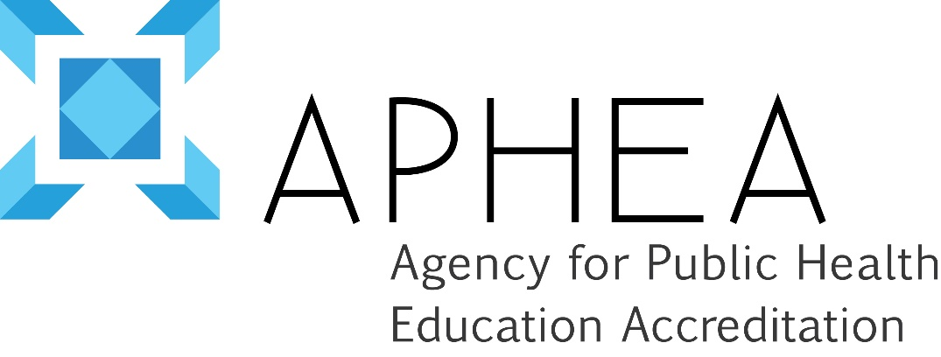

Policy Statement on Conflicts of Interest

Version 1, April 2012
The Agency for Public Health Education Accreditation (APHEA) affirms its commitment to an accreditation process that is characterized by fairness and impartiality. APHEA therefore has a duty to avoid real or perceived conflicts of interest. The potential for a conflict of interest arises when one's duty to make decisions in the public's interest is compromised by competing interests of a professional, personal or private nature.

The obligation of the individual with a conflict of interest which in any way may bias their role as a site visitor for a given programme:
- disclosure of the relationship(s) which constitute(s) or may be perceived as constituting a conflict,
- refusal to accept assignment

APHEA does not seek to exclude from participation all individuals who have or who have ever had any relationship of any nature with an institution subject to accreditation, only those that would potentially bias an accreditation decision in one way or another. To this end, the following safeguards are observed: a) an institution has the right to challenge the involvement of a proposed site visitor based on a perceived conflict of interest and b) the APHEA Board of Directors must approve all proposed site visitors for a given programme.

Numerous relationships might constitute a conflict of interest and the extent to which they do or do not constitute a conflict must be determined on an individual basis. Typical conflicts of interest, provided here as examples only, would include current or former affiliation with the programme being reviewed, affiliation with a competing institution in geographic proximity, a recent or current financial interest in the institution or its activities, alumni status at an institution or other business or professional relationships.
I have read the policy on conflicts of interest and agree to abide by its terms.

NAME (Please print):
SIGNATURE:
DATE:

